ELEC 2110

Electric Circuit Analysis

Gabriel Emerson

Jake Bryson

November 12, 2019

Section 002

Electrical Measurements: AC Power

Introduction

This lab will require the students to breadboard a variety of AC circuits using the NI ELVIS board, and a few basic components. Then the student will make a variety of measurements and then perform an array of calculations.

Exercise 1

Use your digital multimeter to measure the exact value of R.

Summary Table

|  |  |
| --- | --- |
| R (330 Ohm) | 327 Ohm |
| L (0.4 H) | 0.405 H |
| C (10uF) | 9.83 uF |

Exercise 2

Setup Vs(t) using the function generator. Record the oscilloscope’s measured value of the frequency and calculate the corresponding period, T(1/f).

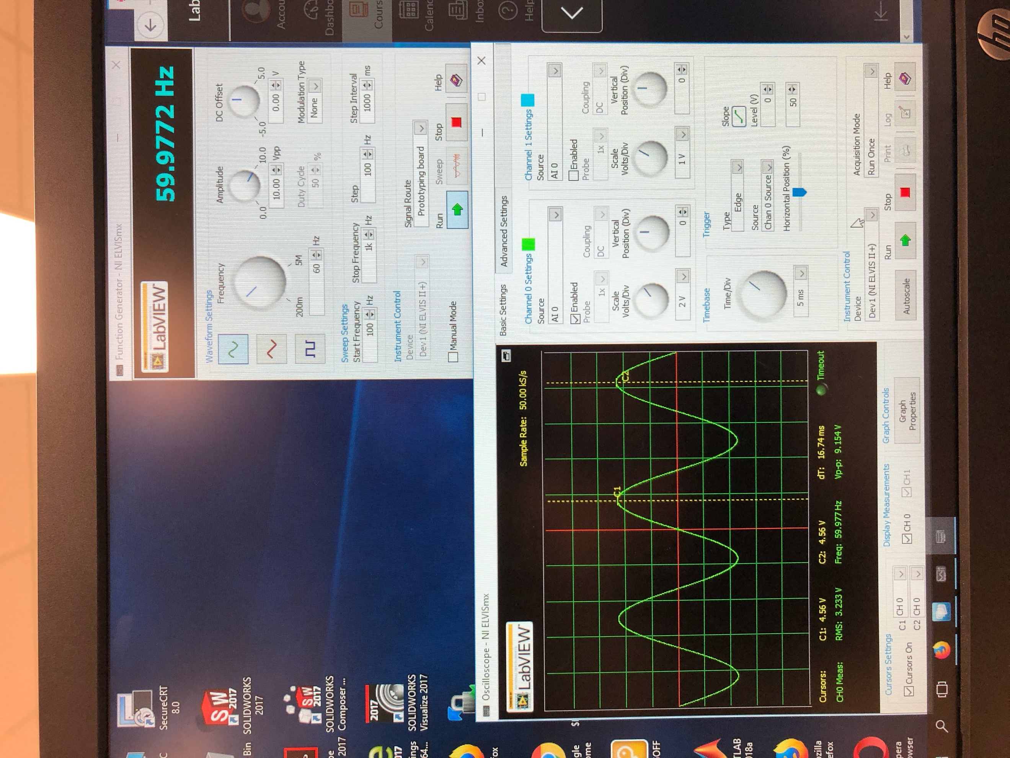

(1)

FGEN and Oscilloscope for exercise 2

Summary Table

|  |  |
| --- | --- |
| Frequency | = 59.977 Hz |
| Period = T(1/f) | = 16.75 Hz |

Exercise 3

Breadboard the circuit given. Then, use the scope to measure and record the RMS voltages. Then find the phase angles of R and C. Then find the following: Phase current, Phase difference between the capacitor voltage and current (is this value what you would expect and why), Complex power absorbed by the load S_load, Power factor of the load pF_load, Series reactance of the load X, the value of C.

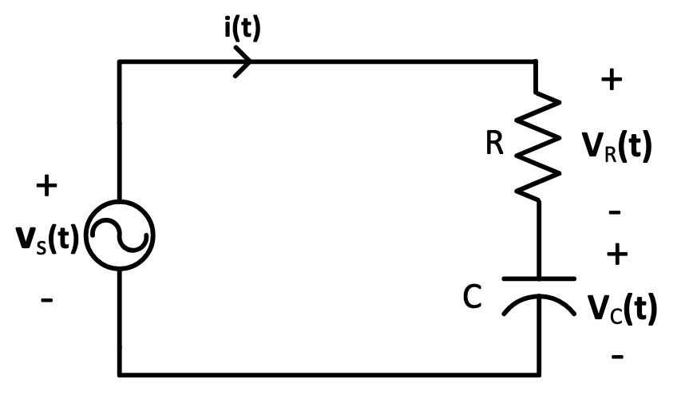

(2)

Circuit given for exercise 3

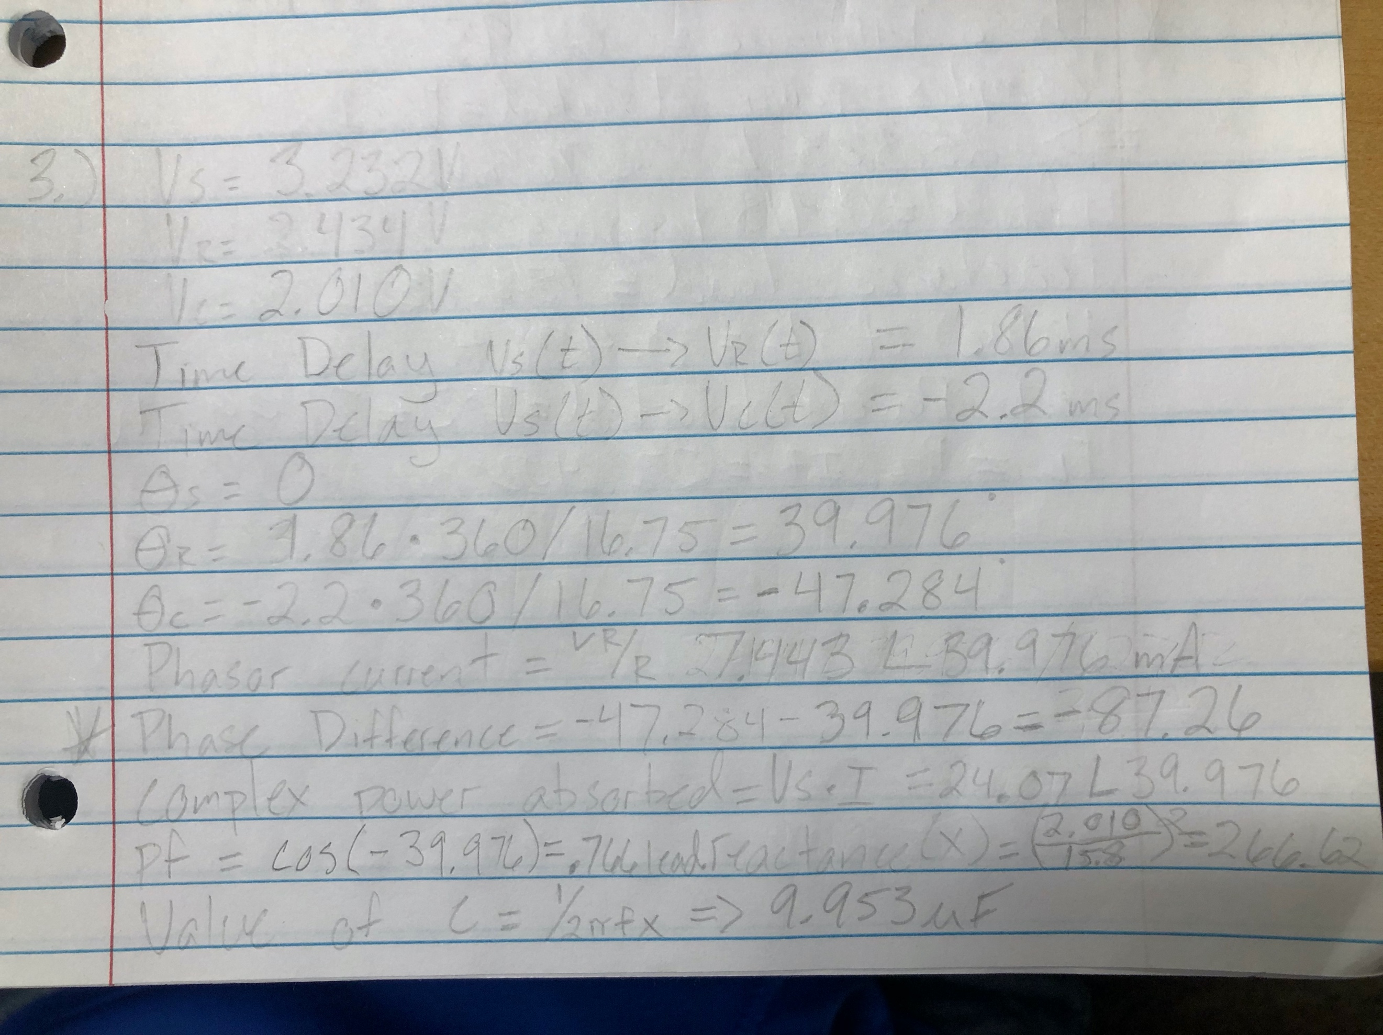

(3)

Equations for exercise 3

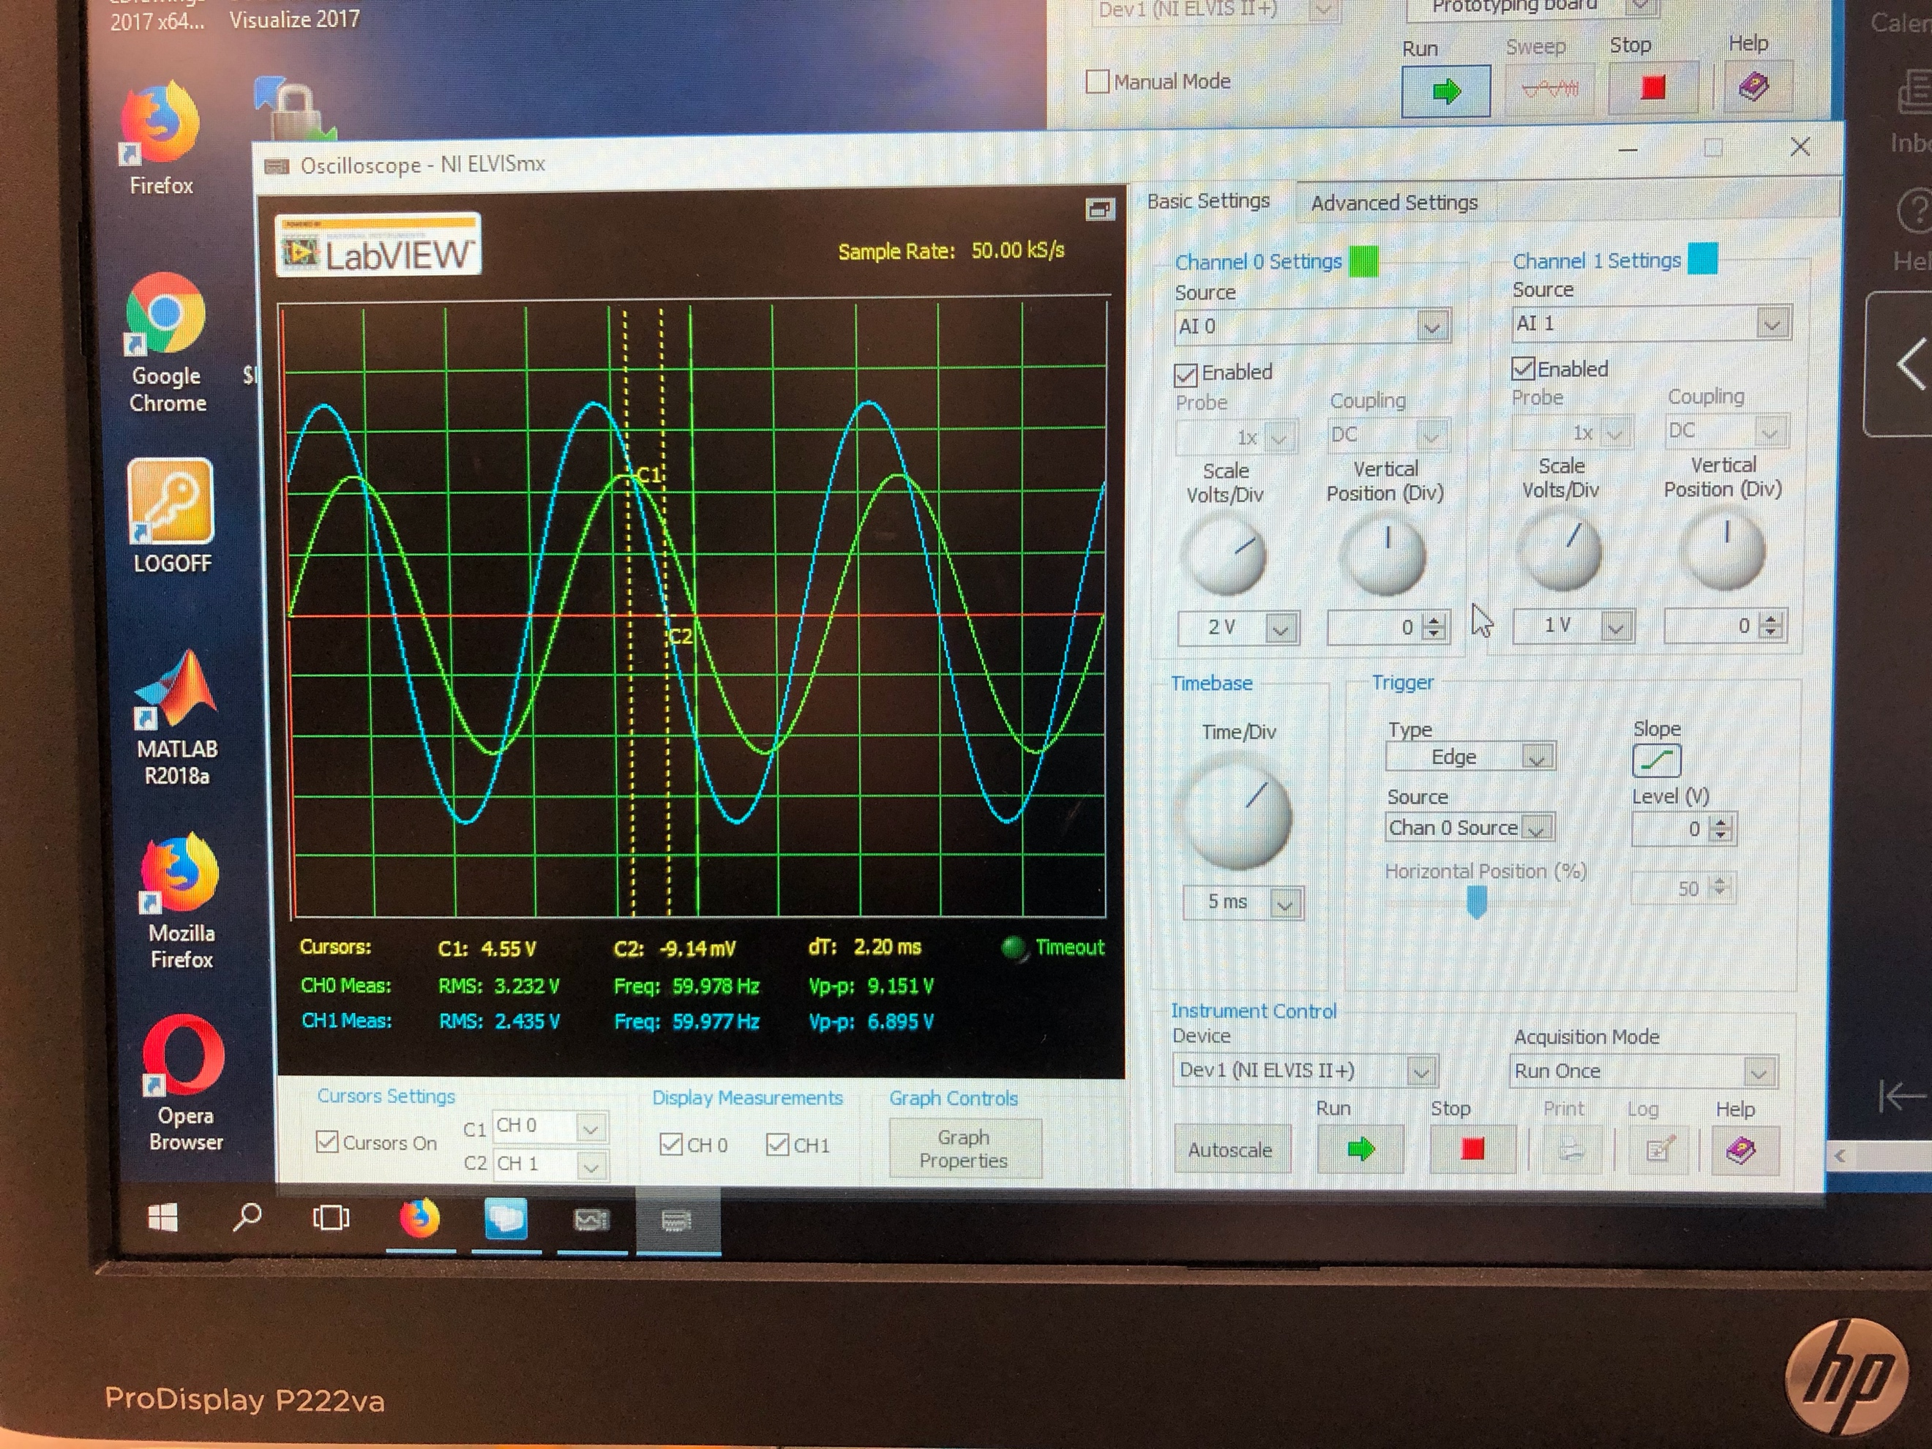

(4)

Scope with time delay of Vs(t) and Vr(t)

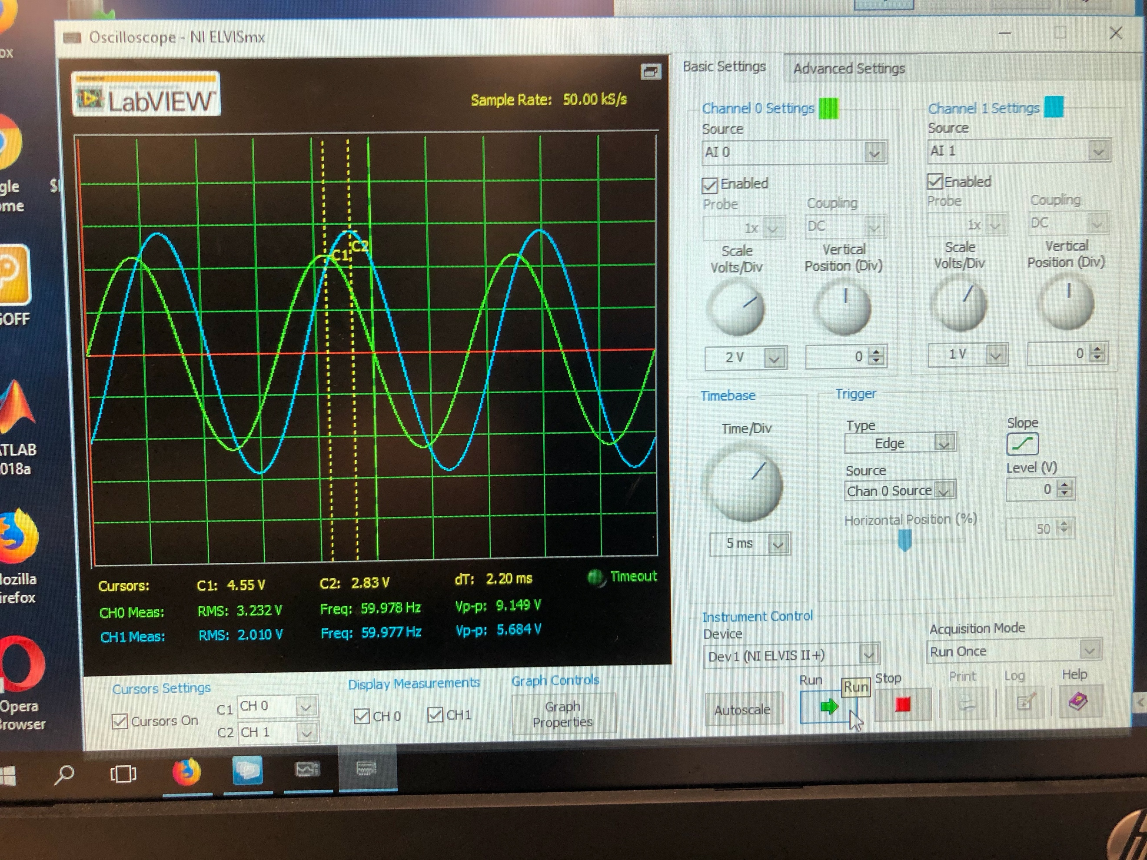

(5)

Scope with time delay of Vs(t) and Vc(t)

Summary Table

|  |  |
| --- | --- |
| **Variable** | **Answer** |
| Vs (RMS) | 3.232 V |
| Vr (RMS) | 2.434 V |
| Vc (RMS) | 2.010 V |
| Time Delay (R) | 1.86 ms |
| Time Delay (C) | -2.2 ms |
| Phase Angle (S) (In Degrees) | 0 |
| Phase Angle (R) (In Degrees) | 39.976 |
| Phase Angle (C) (In Degrees) | -47.284 |
| Phasor Current (I) | 7.443 <39.976 |
| Phase Difference  **Is this what is expected?** | -87.26  **Yes, capacitor voltage should lag current phase by 90 degrees. |
| Complex Power absorbed | 24.07 <39.976 mW |
| Power Factor of the load (pf_load) | 0.7661 leading |
| Series Reactance (X) | 266.62 Ohm |
| Value of C | 9.953 uF |

Exercise 4

Breadboard the circuit given. Then, use the scope to measure and record the RMS voltages. Then find the phase angles of R and L. Then find the following: Phase current, Phase difference between the capacitor voltage and current (is this value what you would expect and why), Complex power absorbed by the load S_load, Power factor of the load pF_load, Series reactance of the load X, the value of L, the real power absorbed by the resistor, the value of the inductors equivalent series resistance (rL).

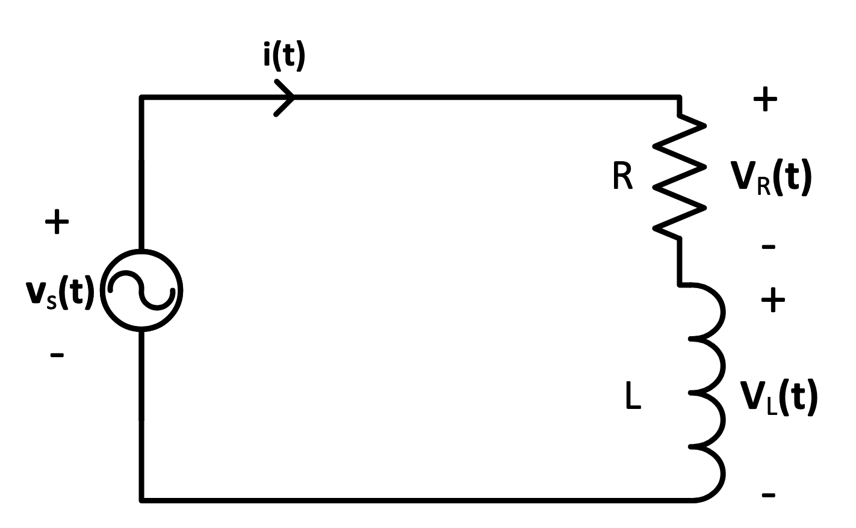

(6)

Circuit given for exercise 4

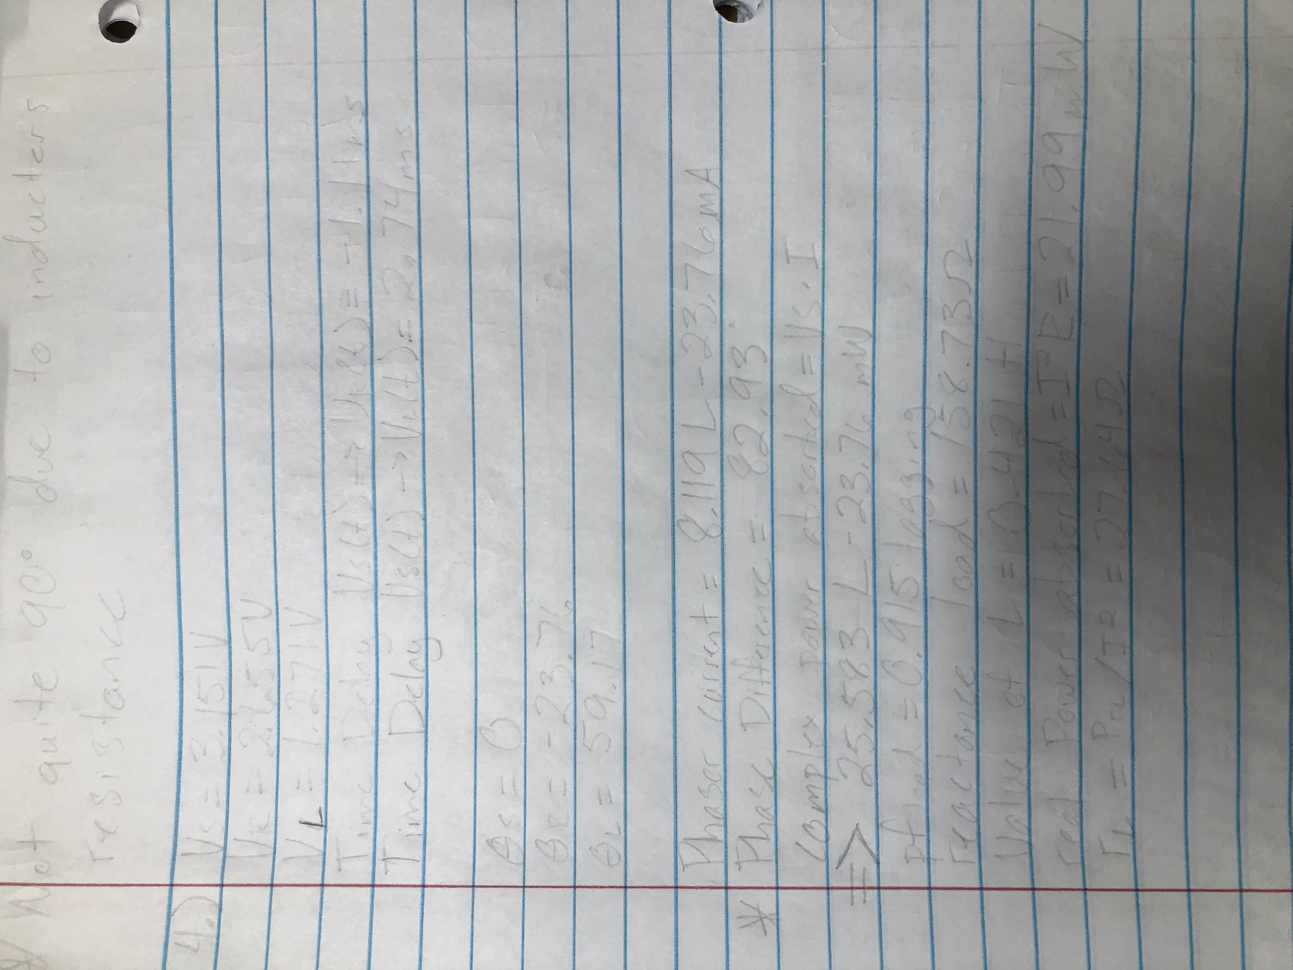

(7)

Equations for exercise 4

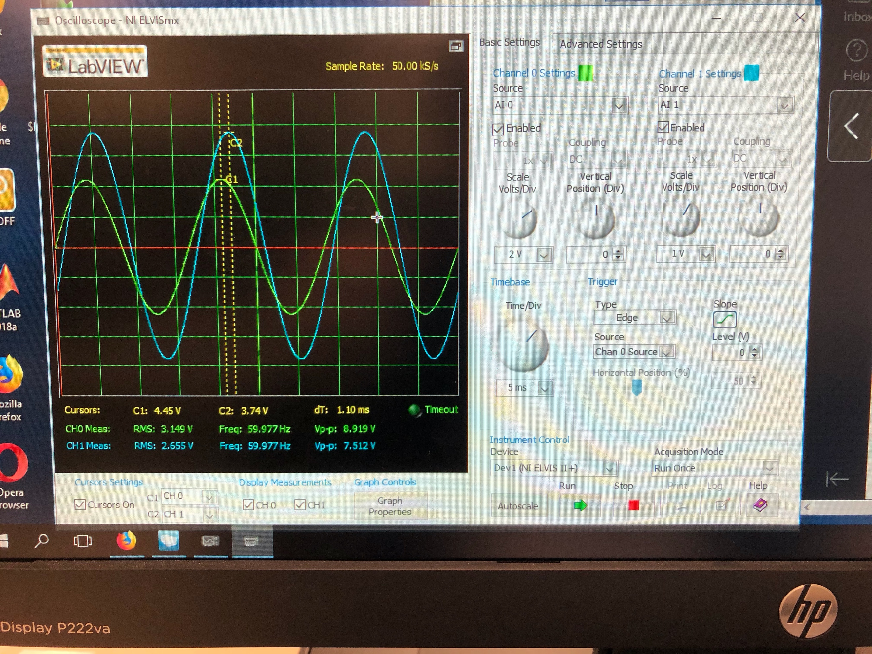

(8)

Scope with time delay of Vs(t) and Vr(t)

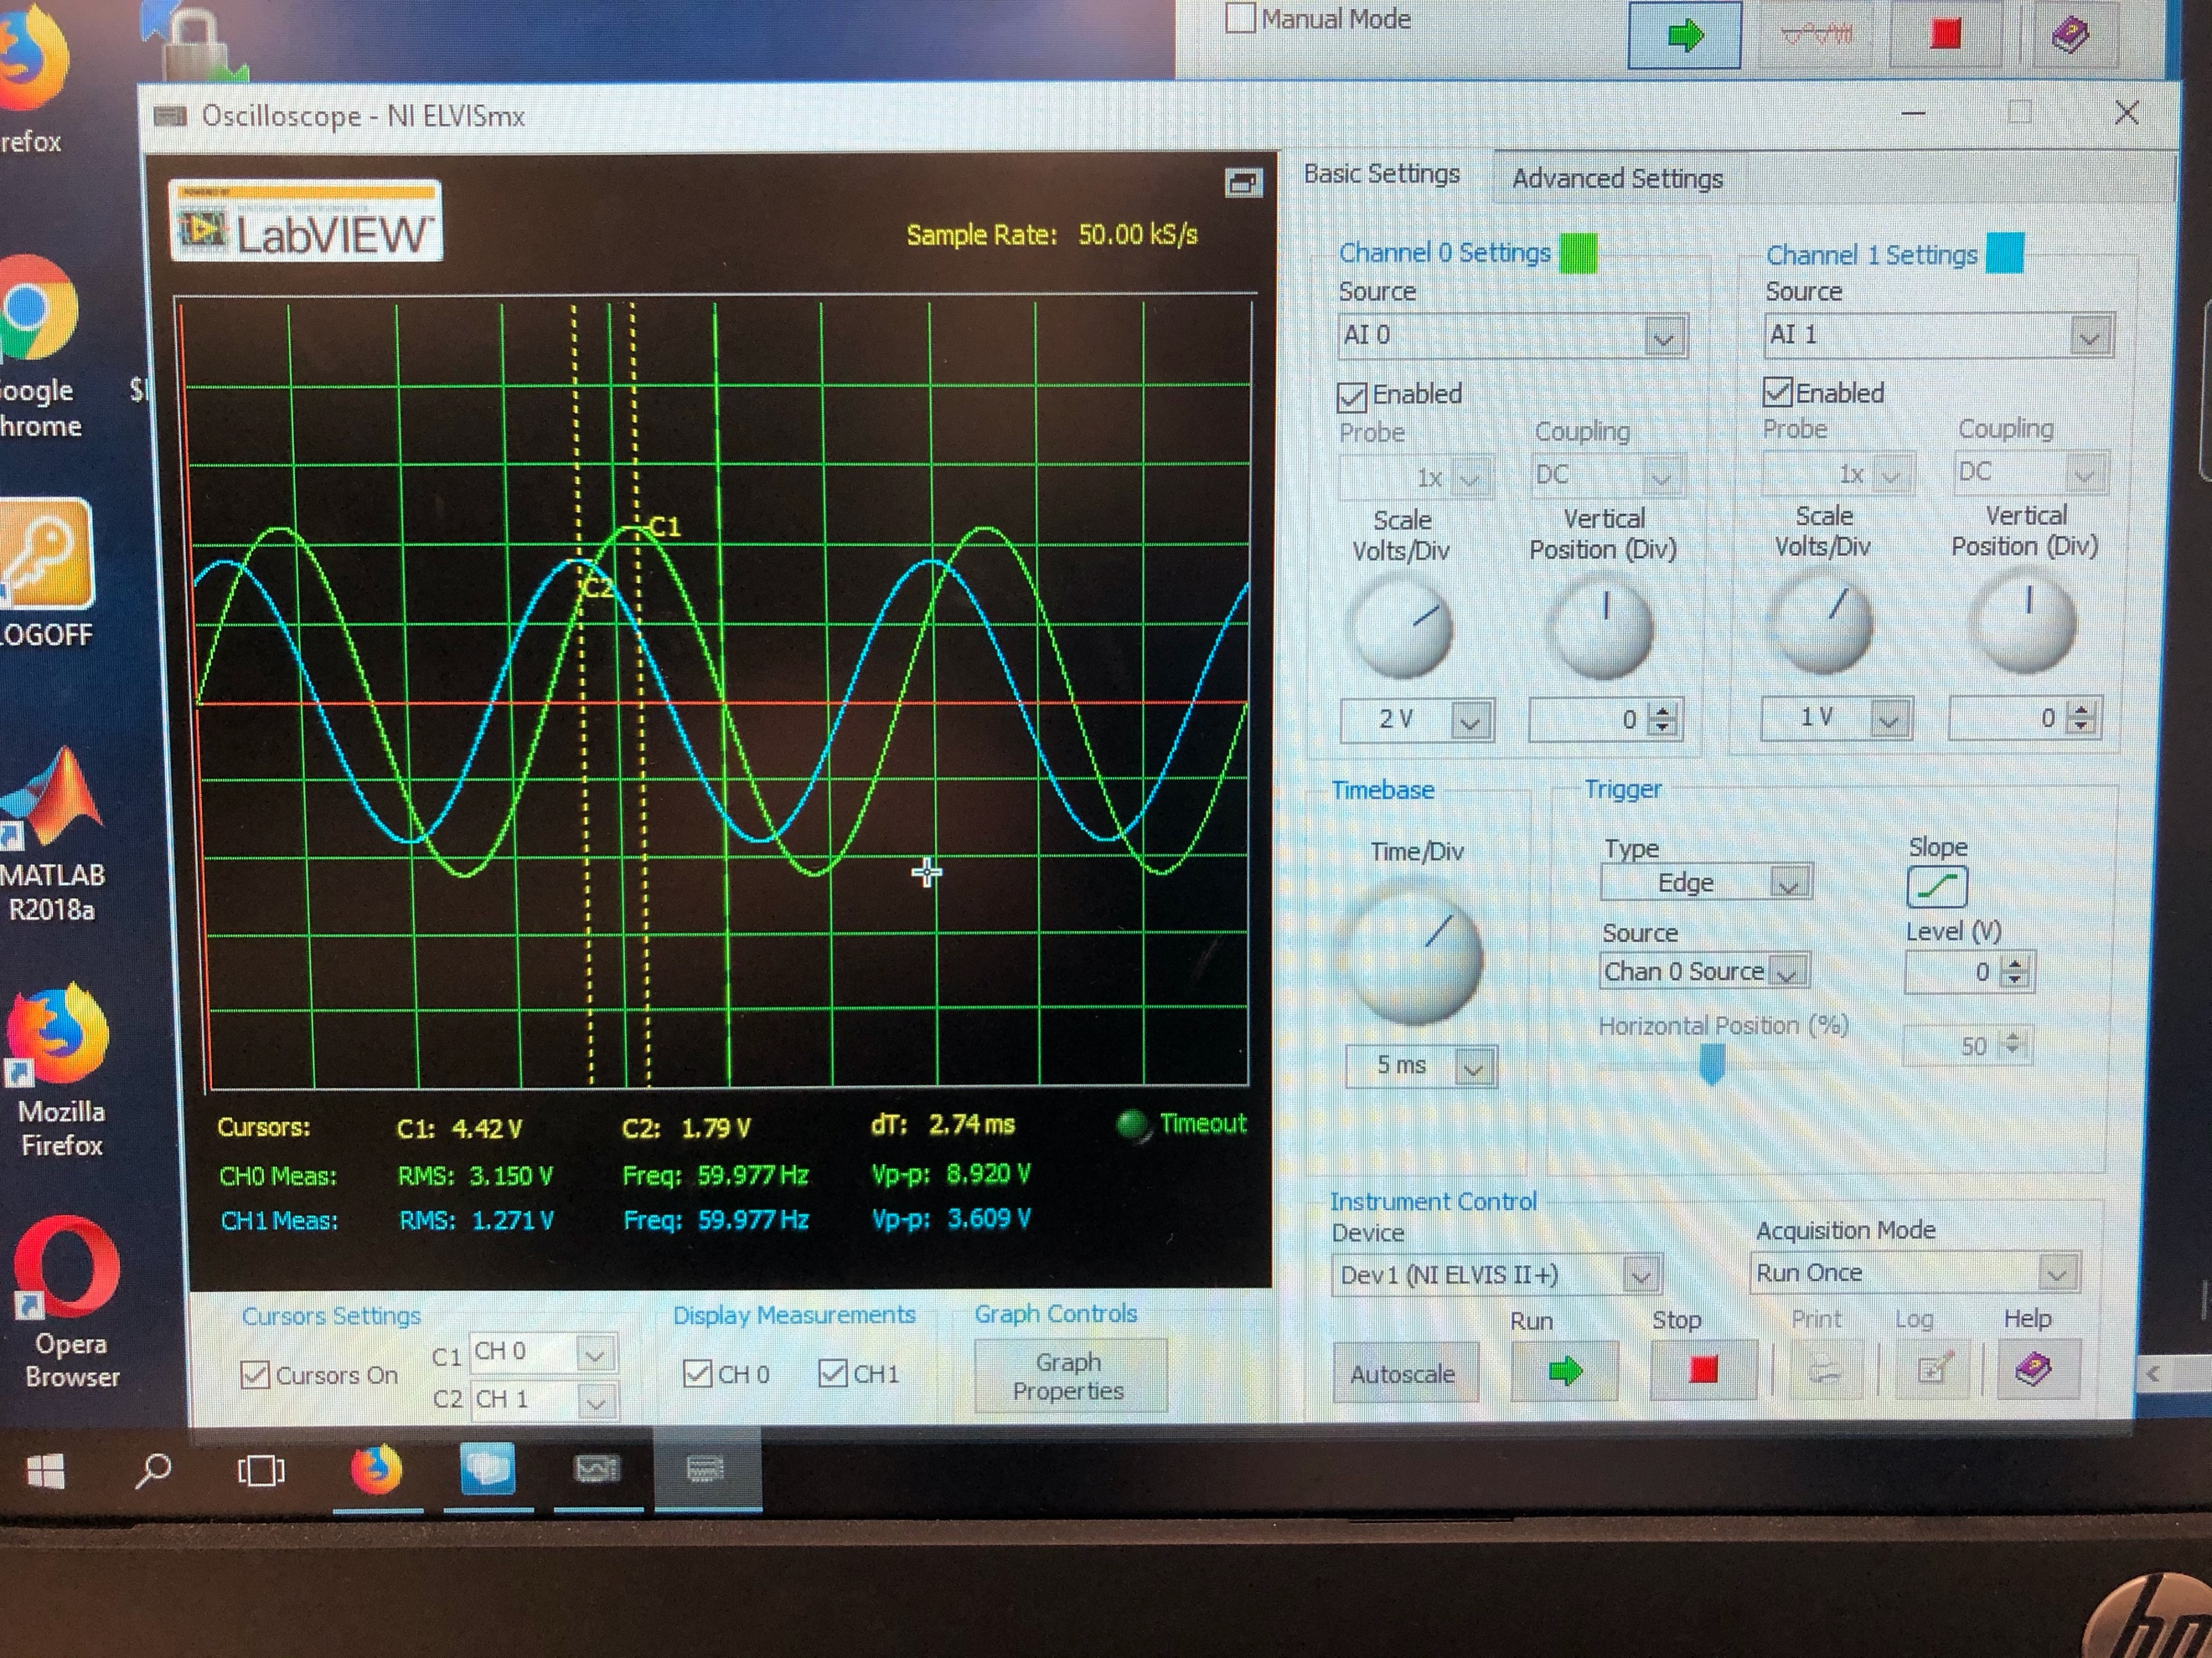

(9)

Scope with time delay of Vs(t) and Vl(t)

Summary Table

|  |  |
| --- | --- |
| **Variable** | **Answer** |
| Vs (RMS) | 3.151 V |
| Vr (RMS) | 2.655 V |
| Vl (RMS) | 1.271 V |
| Time Delay (R) | -1.11 ms |
| Time Delay (L) | 2.74 ms |
| Phase Angle (S) (In Degrees) | 0 |
| Phase Angle (R) (In Degrees) | -23.76 |
| Phase Angle (L) (In Degrees) | 59.17 |
| Phasor Current (I) | 8.119 <-23.76 |
| Phase Difference  **Is this what is expected?** | 82.93  **Not quite 90 degrees due to inductors resistance. |
| Complex Power absorbed | 25.583 <-23.76 mW |
| Power Factor of the load (pf_load) | 0.915 lagging |
| Series Reactance (X) | 158.73 Ohm |
| Value of L | 0.421 H |
| Real Power absorbed | 21.99 mW |
| rL | 27.64 Ohm |

Exercise 5

Breadboard the circuit given. Then, use the scope to measure and record the RMS voltages. Then find the phase angles of R, L, and C. Then find the following: Phase current, Complex power absorbed by the load S_load, Power factor of the load pF_load, Complex Power absorbed individually by R, L, and C (and confirm they equal total real power absorbed), the equivalent series load impedence Z. Also write the full expressions for Vs(t), Vr(t), Vl(t), Vc(t), and i(t).

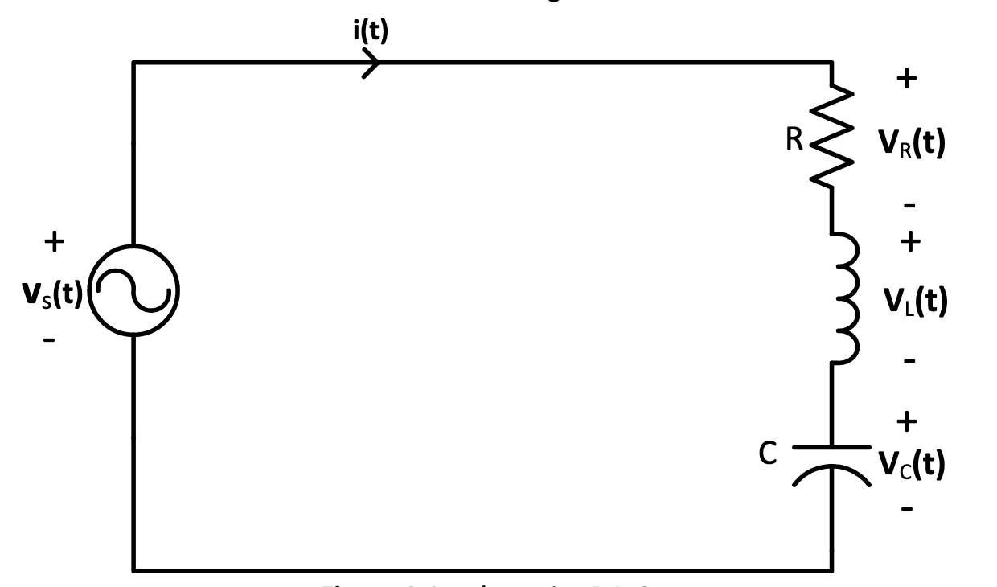

(10)

Circuit given for exercise 5

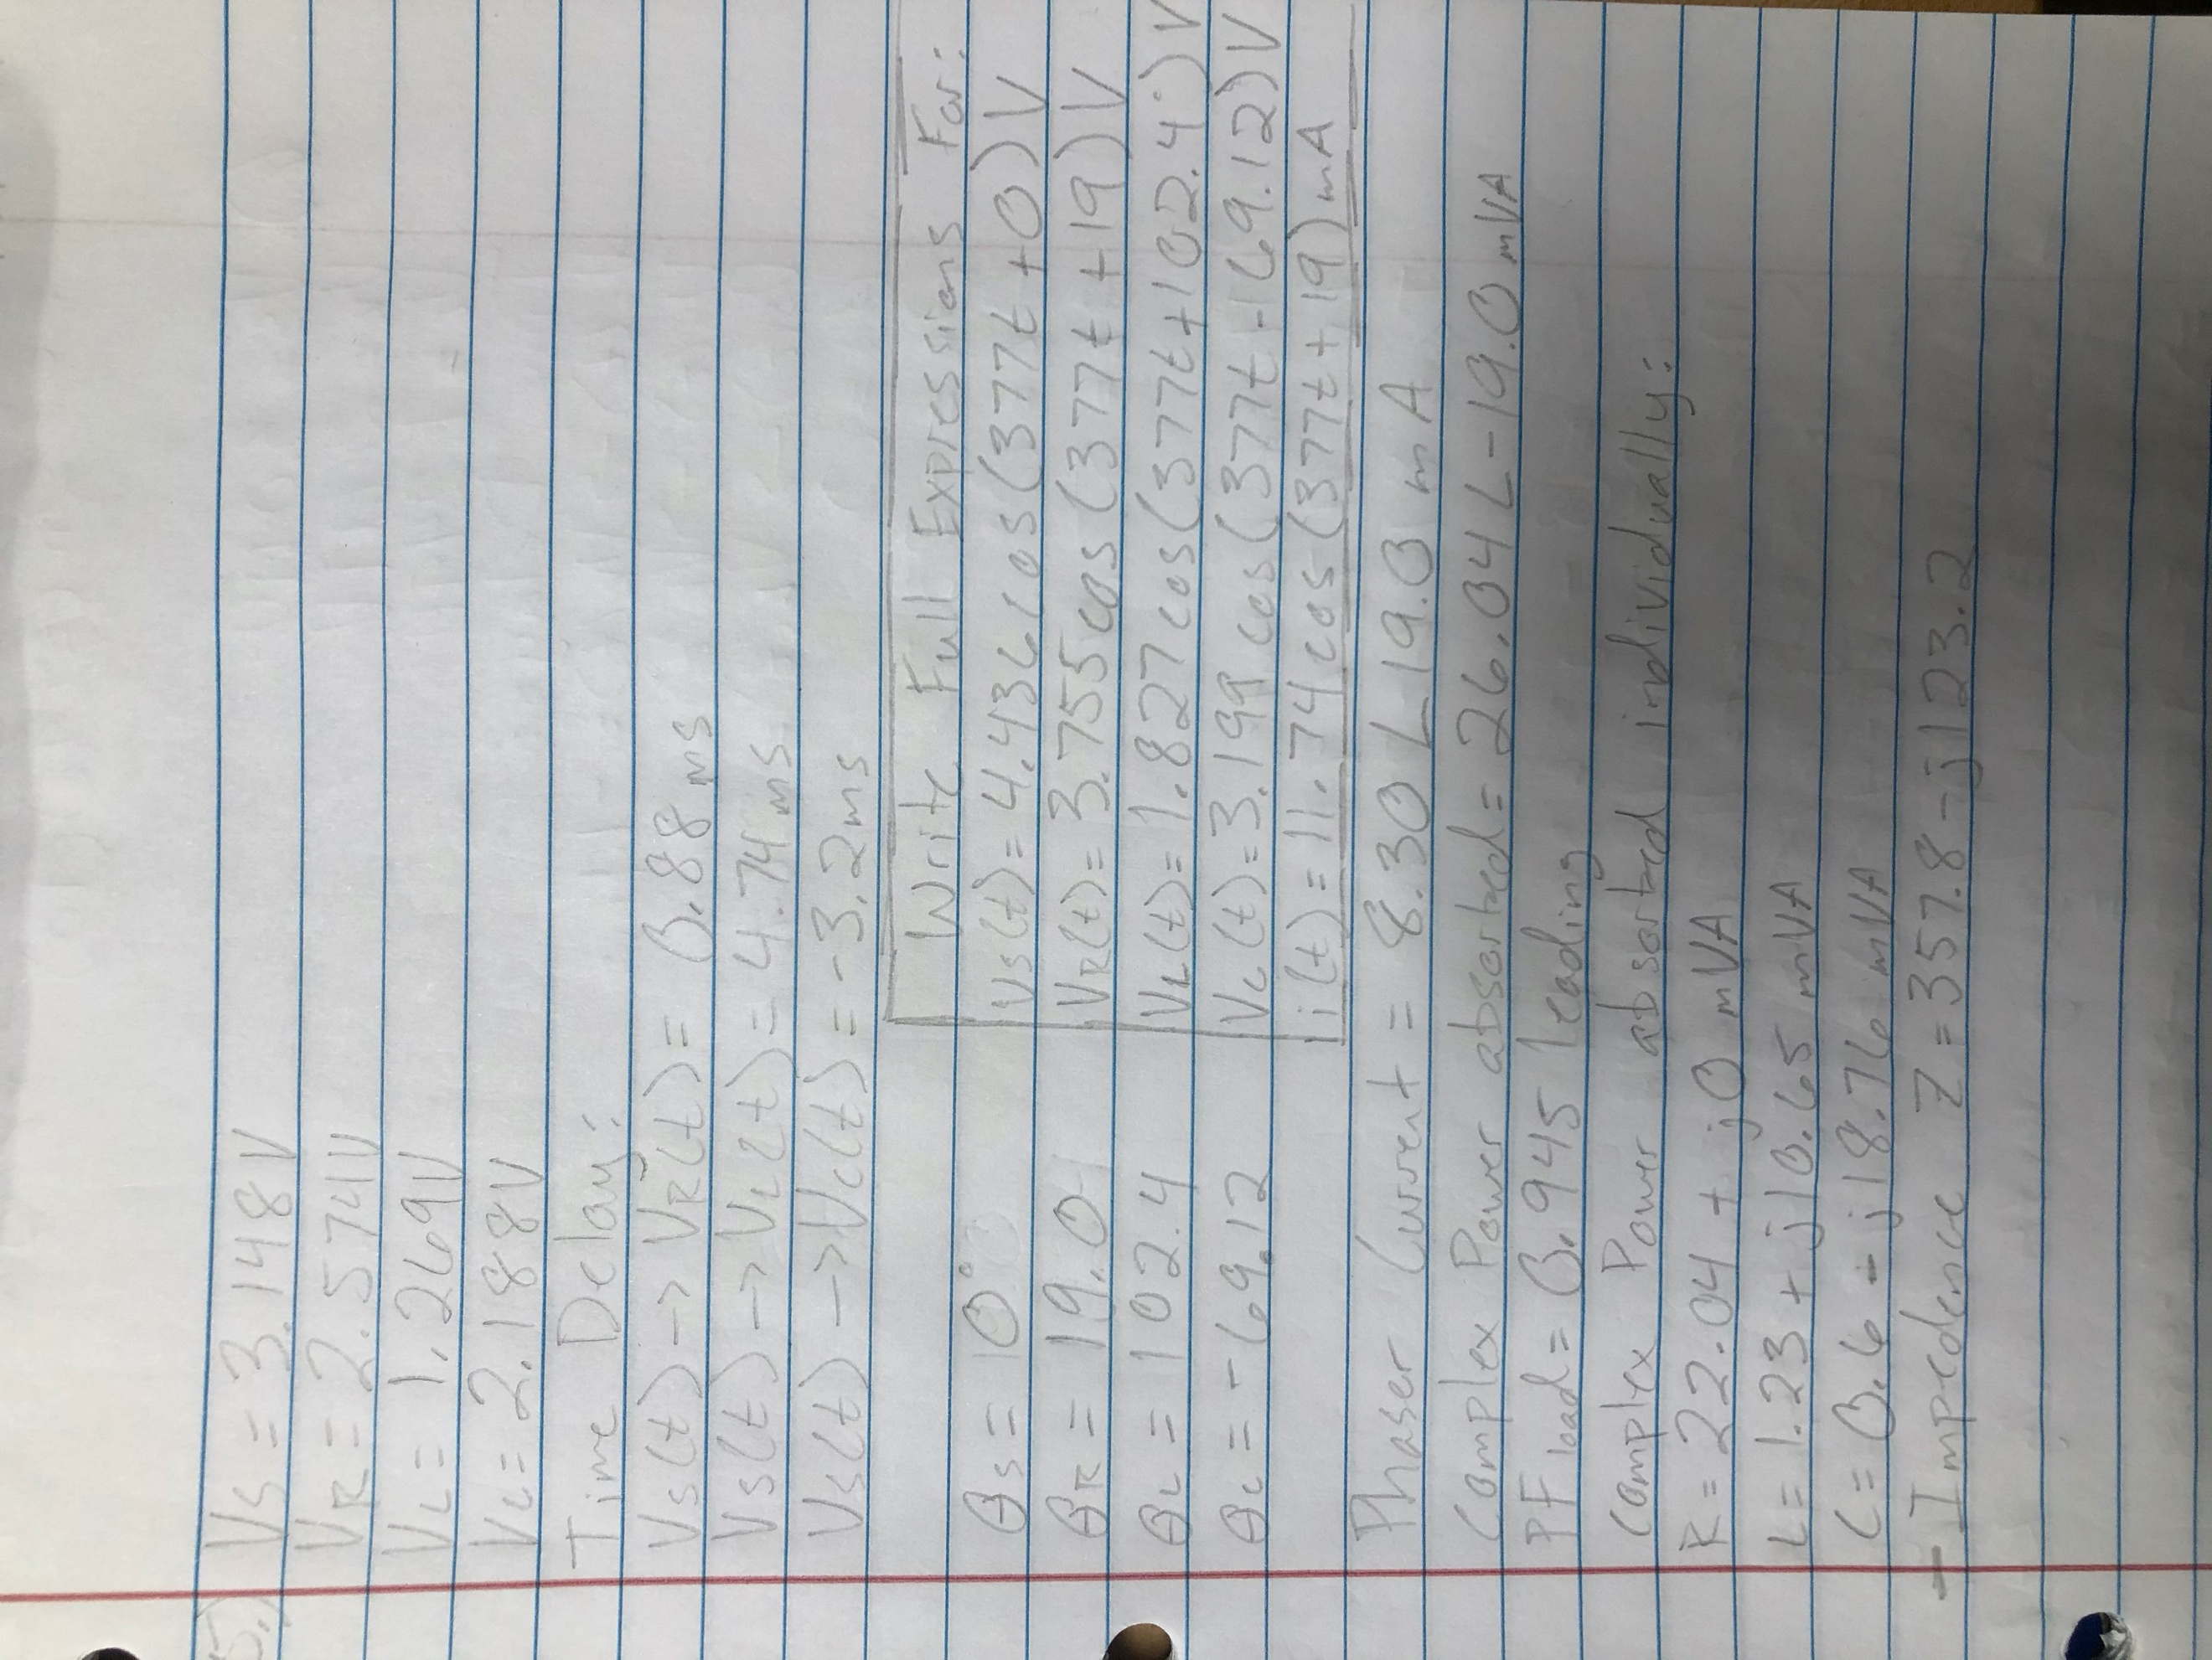

(11)

Equations for exercise 5

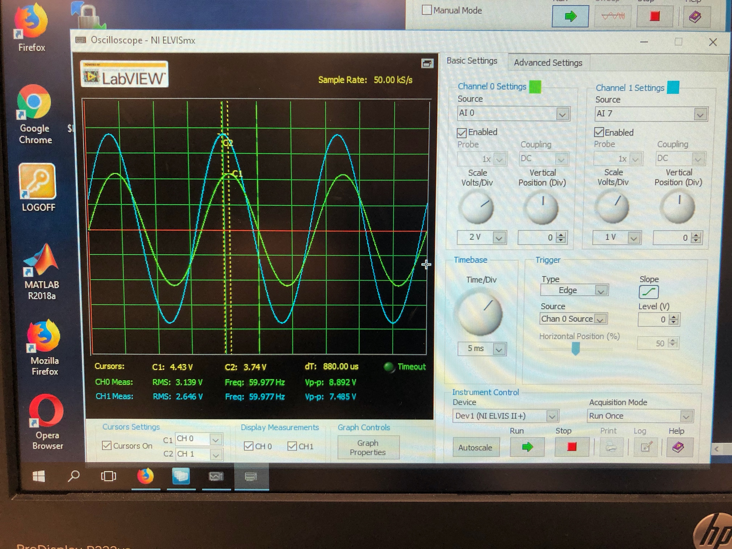

(12)

Scope with time delay of Vs(t) and Vr(t)

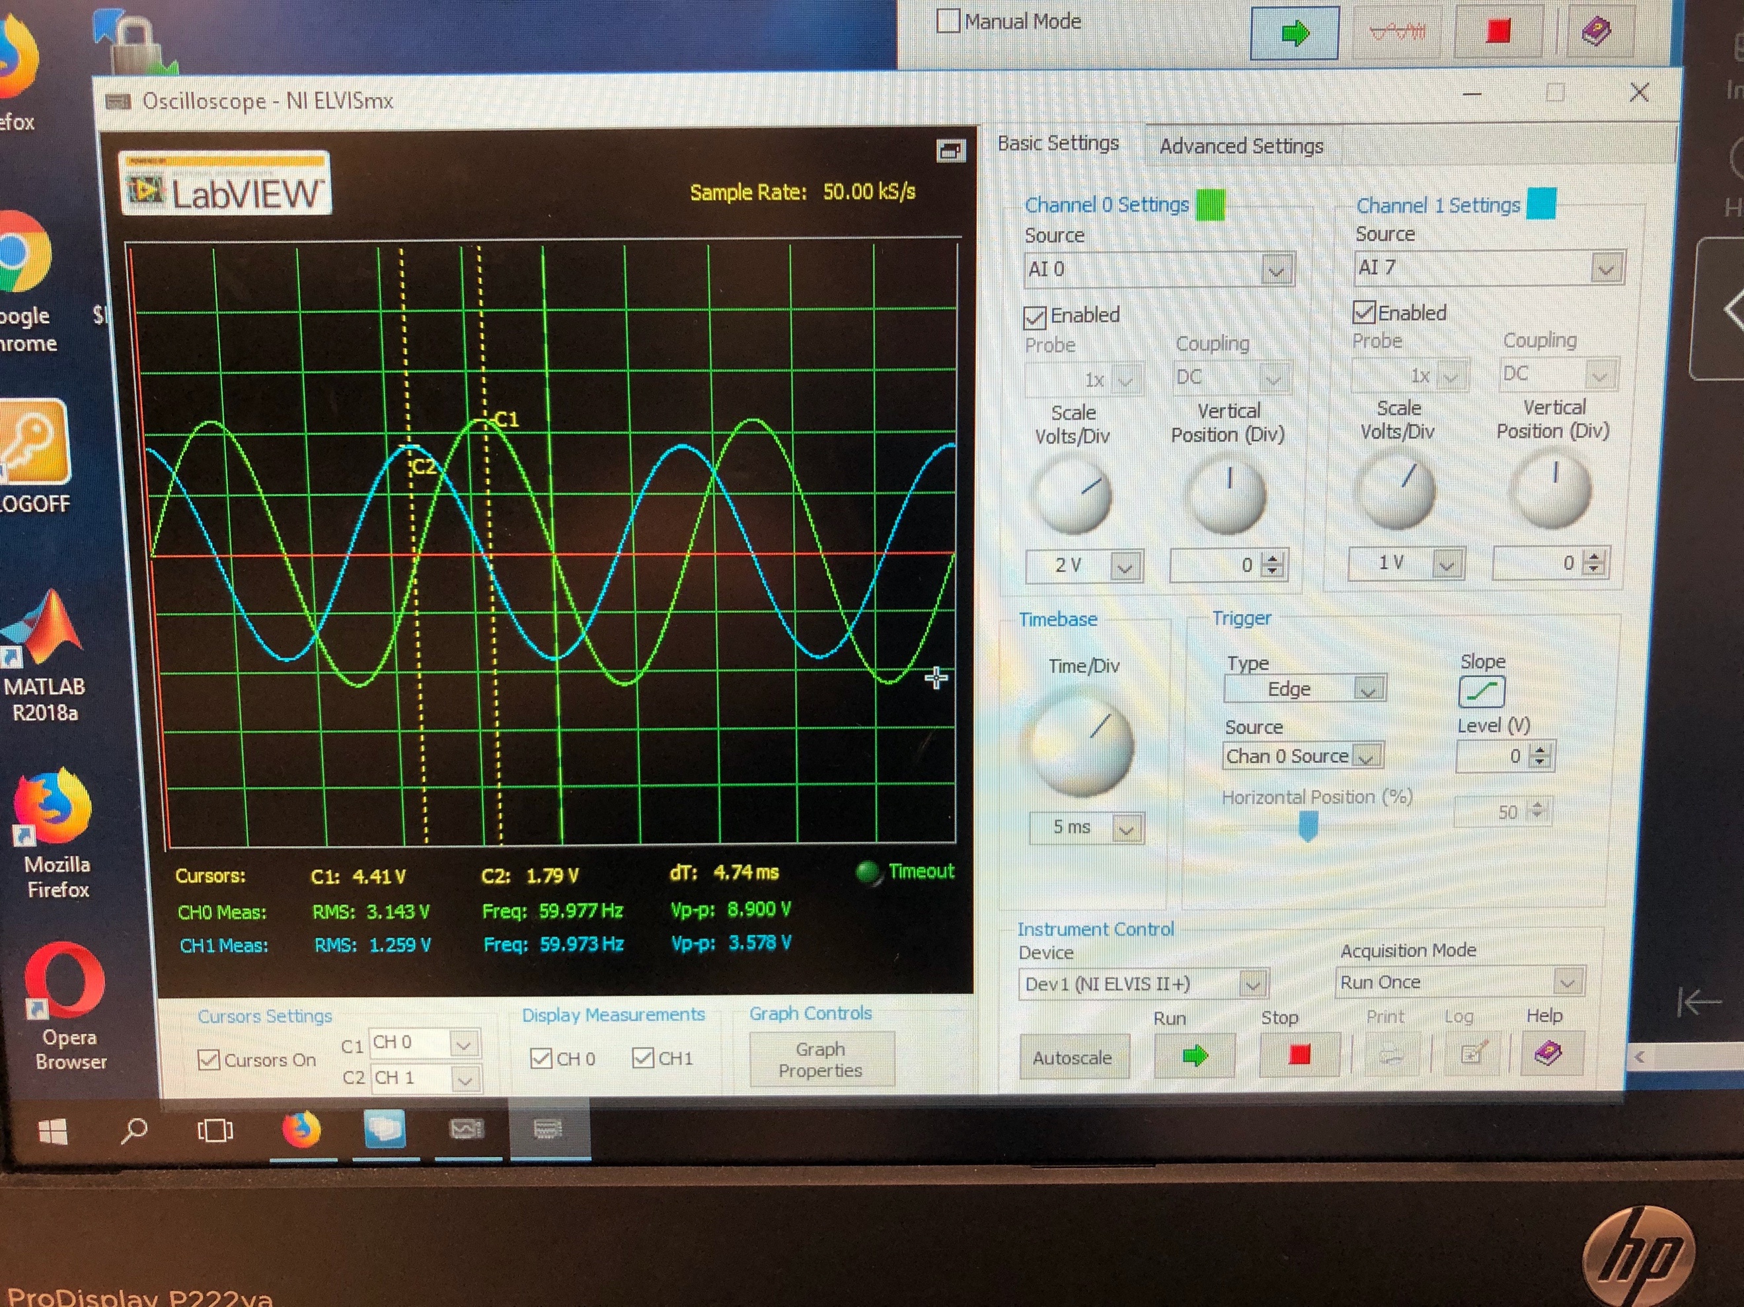

(13)

Scope with time delay of Vs(t) and Vl(t)

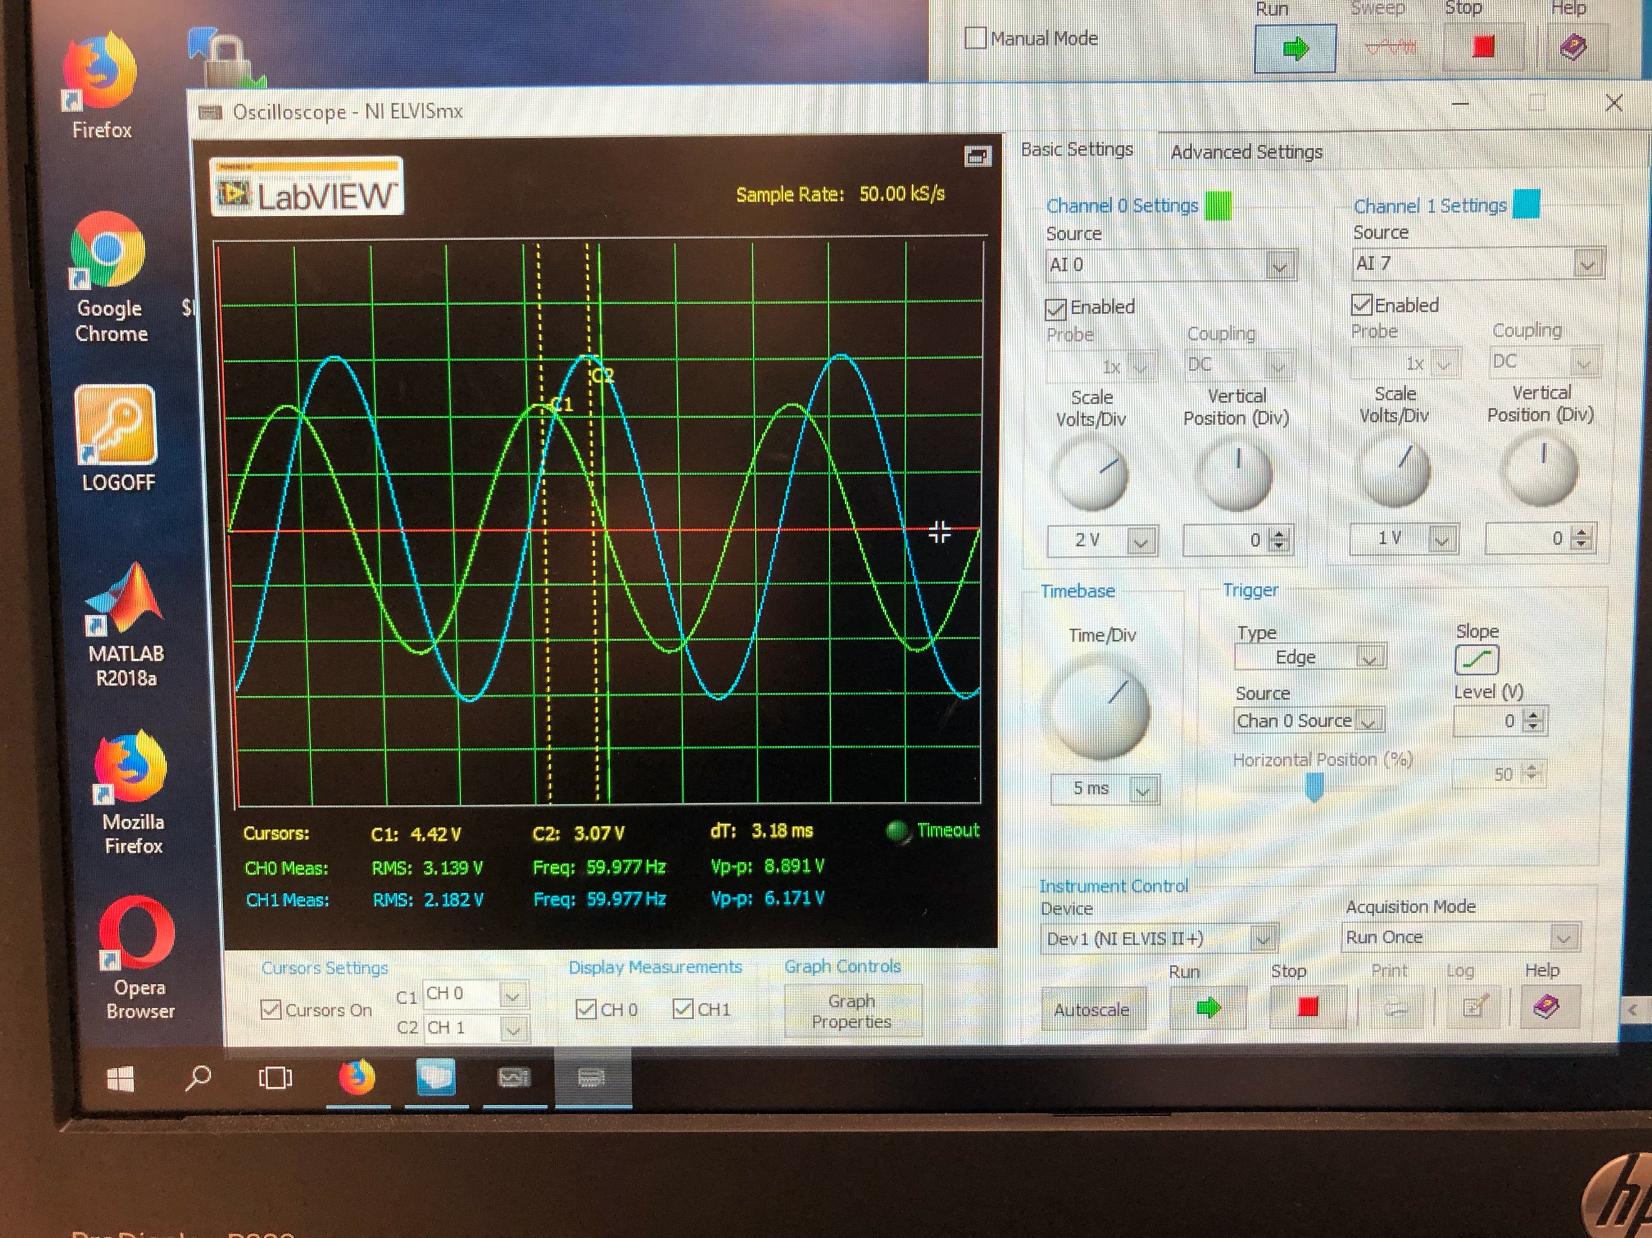

(14)

Scope with time delay of Vs(t) and Vc(t)

Summary Table

|  |  |
| --- | --- |
| Vs (RMS) | 3.148 V |
| Vr (RMS) | 2.574 V |
| Vl (RMS) | 1.269 V |
| Vc (RMS) | 2.188 V |
| Time Delay Vs(t)🡪Vr(t) | 0.88 ms |
| Time Delay Vs(t)🡪Vl(t) | 4.74 ms |
| Time Delay Vs(t)🡪Vc(t) | -3.20 ms |
| Phase Angle (S) (Degrees) | 0 |
| Phase Angle (R) (Degrees) | 19.0 |
| Phase Angle (L) (Degrees) | 102.4 |
| Phase Angle (C) (Degrees) | -69.12 |
| Phasor Current | 8.30 <19.0 mA |
| Complex Power Absorbed | 26.04 <-19.0 mVA |
| pF_load | 0.945 leading |
| Complex power absorbed individual:   1. Resistor (R) 2. Inductor (L) 3. Capacitor (C) | 1. 22.04 <0 mVA 2. 10.721 <83.4119 mVA 3. 18.7696 <-88.1681 mVA |
| Impedance (Z) | 378.417 <-18.999 Ohm |

Write Full Expressions for:

Vs(t) = 4.436*cos(377t+0) V

Vr(t) = 3.755*cos(377t+19) V

Vl(t) = 1.827*cos(377t+102.4) V

Vc(t) = 3.199*cos(377t-69.12) V

i(t) = 11.74*cos(377t+19) mA

Exercise 6

Breadboard the circuit given. Then, use the scope to measure and record the RMS voltages. Then find the phase angles of R, L, and C. Then find the following: Phase currents (Ir and Ic), Complex power absorbed by the C branch and by the R-L branch, Complex total power absorbed S_load, Power factor of the load pF_load (**To obtain a unity power factor (pf_Load = 1), should the parallel capacitor be increased or decreased**), the equivalent series load impedence Z.

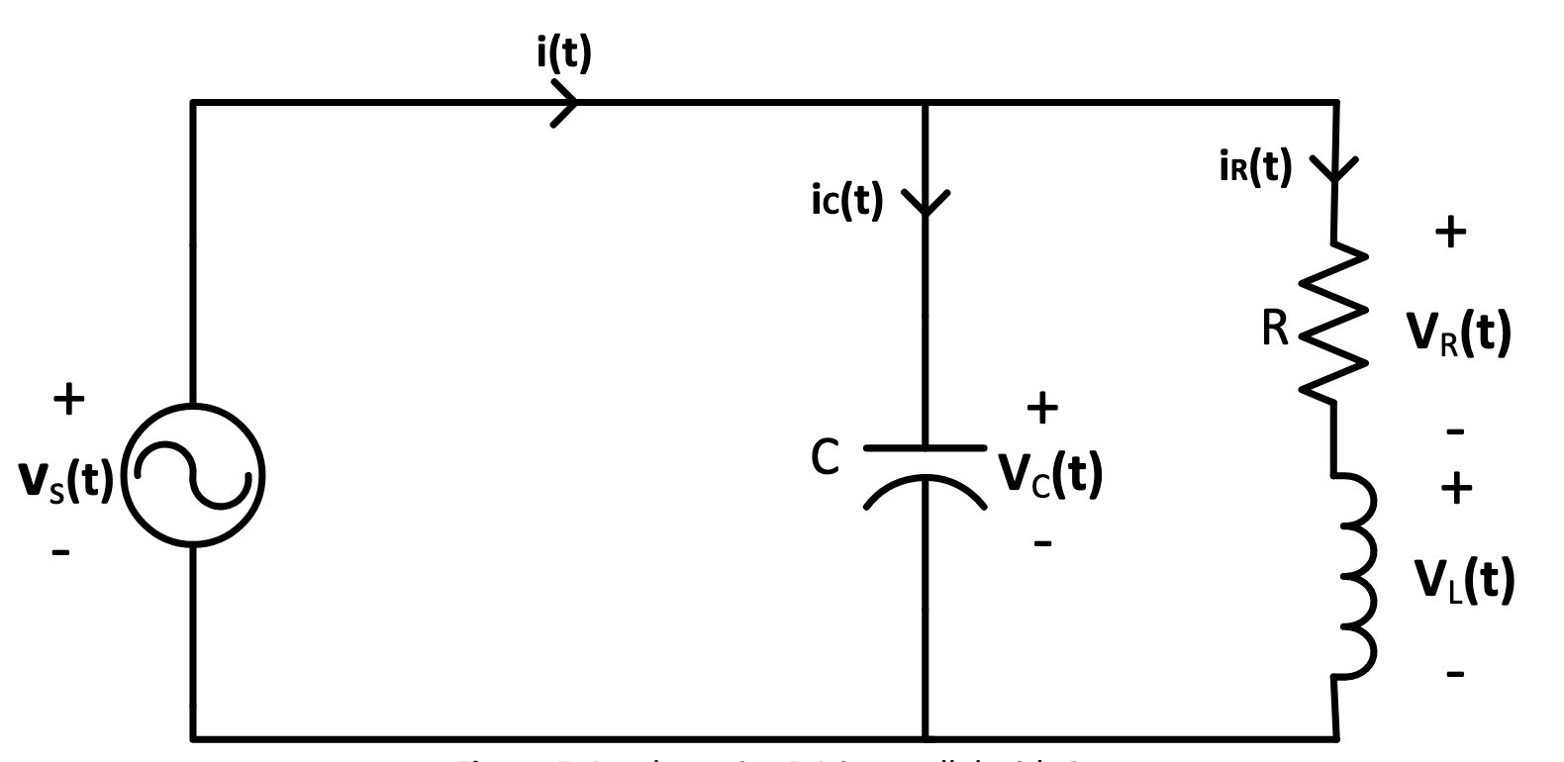

(15)

Circuit given for exercise 6

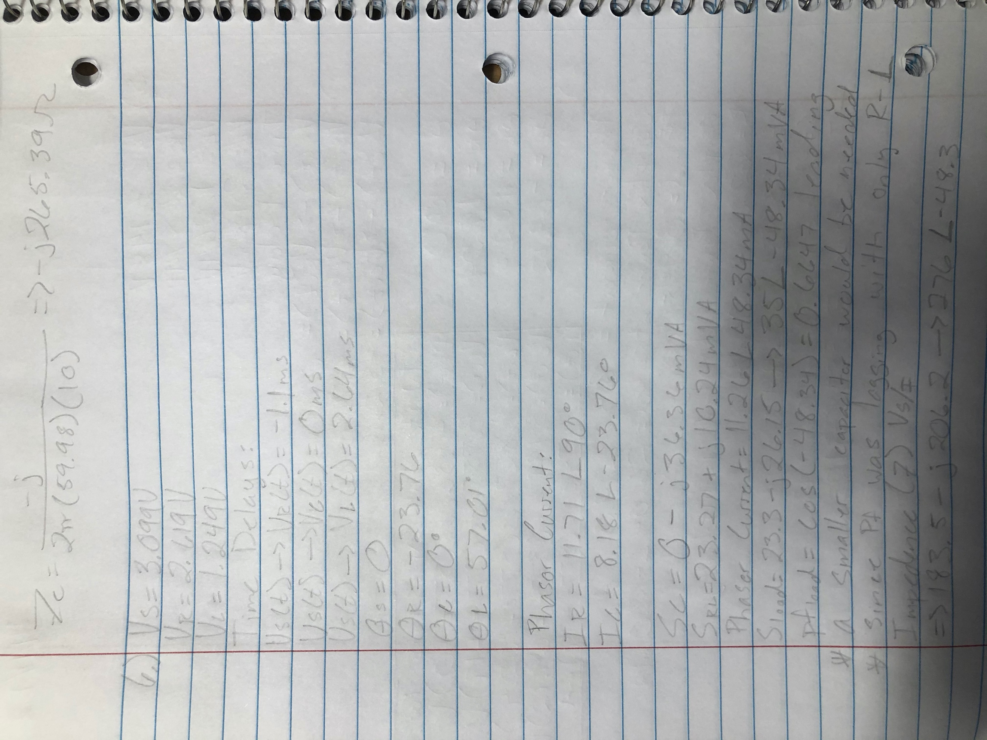

(16)

Equations for exercise 6

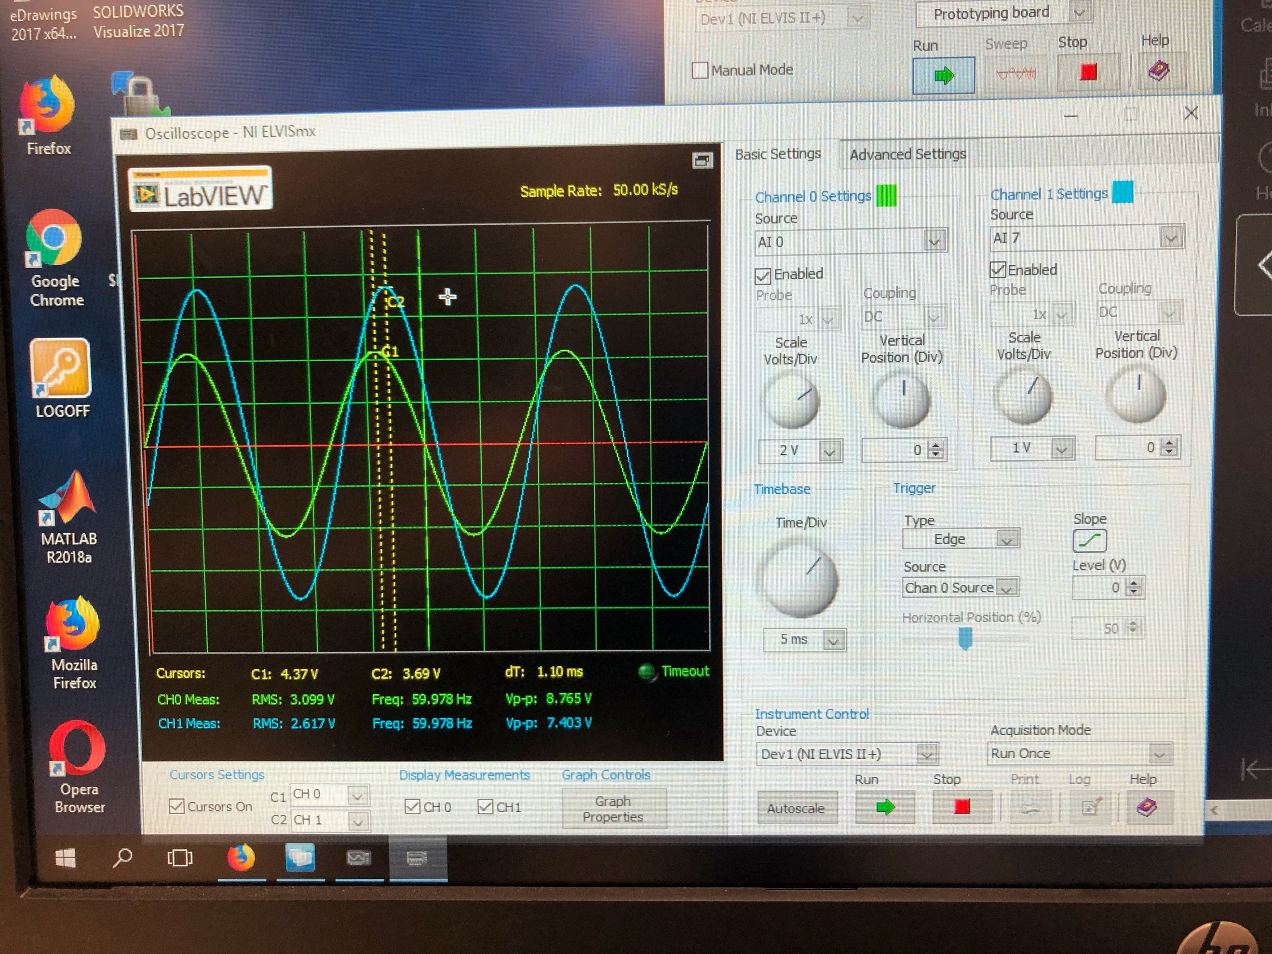

(17)

Scope with time delay of Vs(t) and Vr(t)

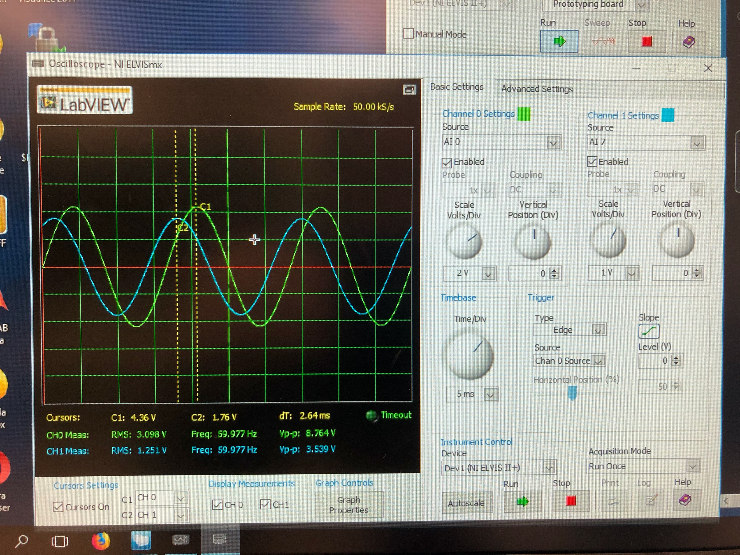

(18)

Scope with time delay of Vs(t) and Vl(t)

Summary Table

|  |  |
| --- | --- |
| Vs (RMS) | 3.099 V |
| Vr (RMS) | 2.619 V |
| Vl (RMS) | 1.249 V |
| Time Delay Vs(t)🡪Vr(t) | -1.10 ms |
| Time Delay Vs(t)🡪Vl(t) | 2.64 ms |
| Time Delay Vs(t)🡪Vc(t) | 0 ms |
| Phase Angle (S) (Degrees) | 0 |
| Phase Angle (R) (Degrees) | -23.76 |
| Phase Angle (L) (Degrees) | 57.01 |
| Phase Angle (C) (Degrees) | 0 |
| Phasor Current (Ir) | 11.71 <90 |
| Phasor Current (Ic) | 8.18 <-23.76 |
| Complex Power Absorbed:   1. C-branch 2. R-L branch 3. Total (S_load) | 1. 36.36 <-90 mVA 2. 25.4234 <23.752 3. 34.9821 <-48.3025 |
| pF_load  ** To obtain a unity power factor (pF_Load = 1), should the parallel capacitor be increased or decreased?** | 0.6647 leading  **A smaller capacitor would be needed since pF was lagging with only R-L in the circuit** |
| Impedence (Z) | 276 <-48.3 Ohm |

Conclusion

This lab is quite important since it gives real-world scenarios to the student to solve. Since we have studied all of circuit engineering, we have no moved past that and are now studying power lines and how AC circuits affect the real world. The knowledge of power and how to calculate certain parts of it, is very important to an electrical engineer since it is one of the main routes and electrical engineer can go.

Bibliography

1. FGEN and Oscilloscope for exercise 2
2. Circuit given for exercise 3
3. Equations for exercise 3
4. Oscilloscope with time delay for Vs(t) to Vr(t)
5. Oscilloscope with time delay for Vs(t) to Vc(t)
6. Circuit given for exercise 4
7. Equations for exercise 4
8. Oscilloscope with time delay for Vs(t) to Vr(t)
9. Oscilloscope with time delay for Vs(t) to Vl(t)
10. Circuit given for exercise 5
11. Equations for exercise 5
12. Oscilloscope with time delay for Vs(t) to Vr(t)
13. Oscilloscope with time delay for Vs(t) to Vl(t)
14. Oscilloscope with time delay for Vs(t) to Vc(t)
15. Circuit given for exercise 6
16. Equations for exercise 6
17. Oscilloscope with time delay for Vs(t) to Vr(t)
18. Oscilloscope with time delay for Vs(t) to Vl(t)